
Name___________________________

Maths Specialist - Investigation

Circle Geometry- Part Two

Extended investigation Part 2: In-class validation

Question 1 (6 marks)

Write a description of the theorem next to the diagram.
(a) Angle in a Semicircle (1)
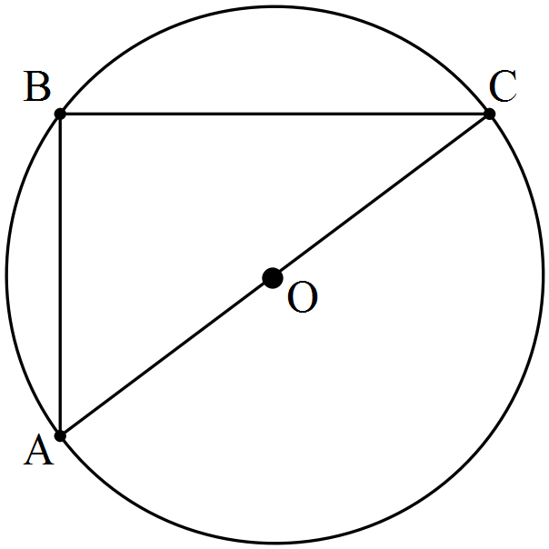

(b) Central Angle Theorem (1)
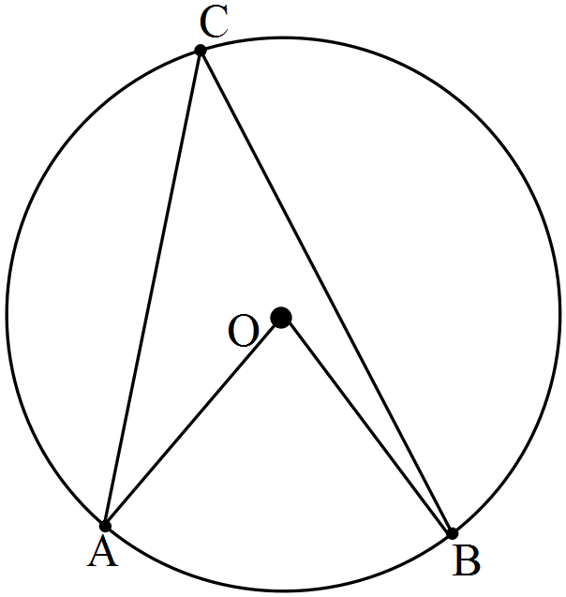

(c) Angle in the Alternate Segment Theorem (1)
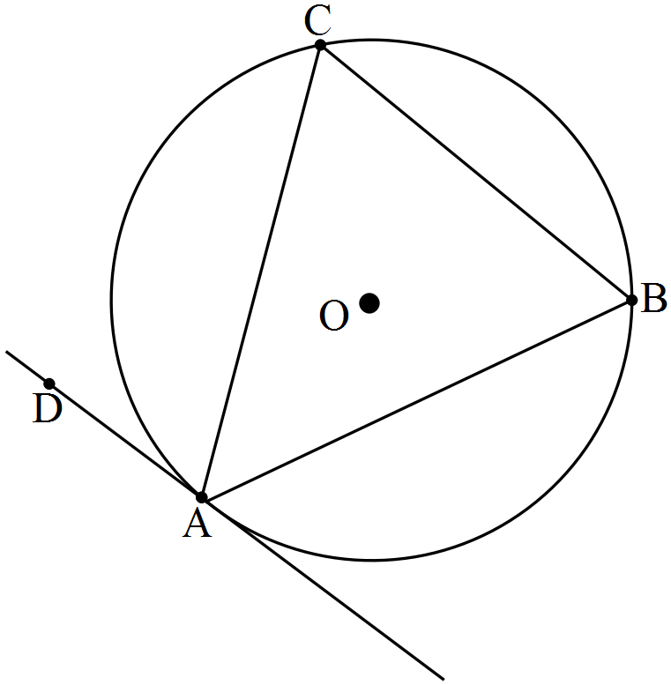

(d) Length of Tangents Theorem (1)
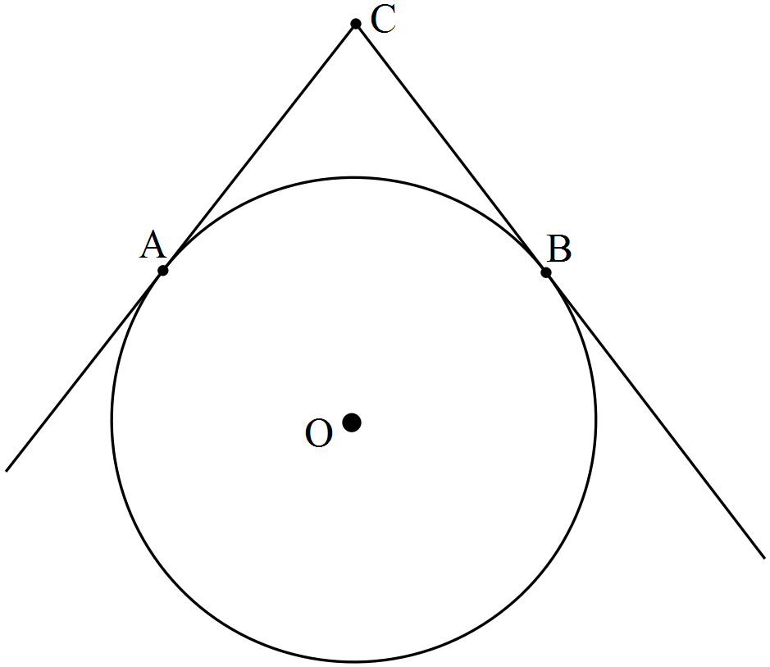

e) Intersecting Chords Theorem (1)
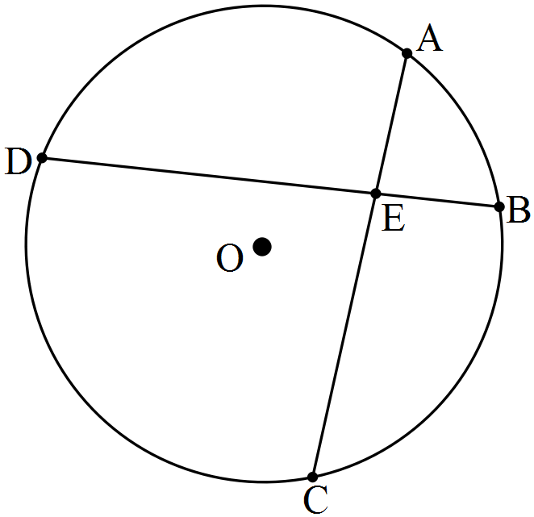

(f) Angles at the circumference of a circle subtended by the same arc. (1)
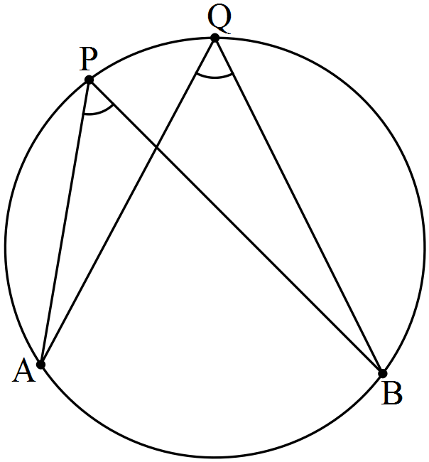

Question 2 (5 marks)

Complete the following proof.
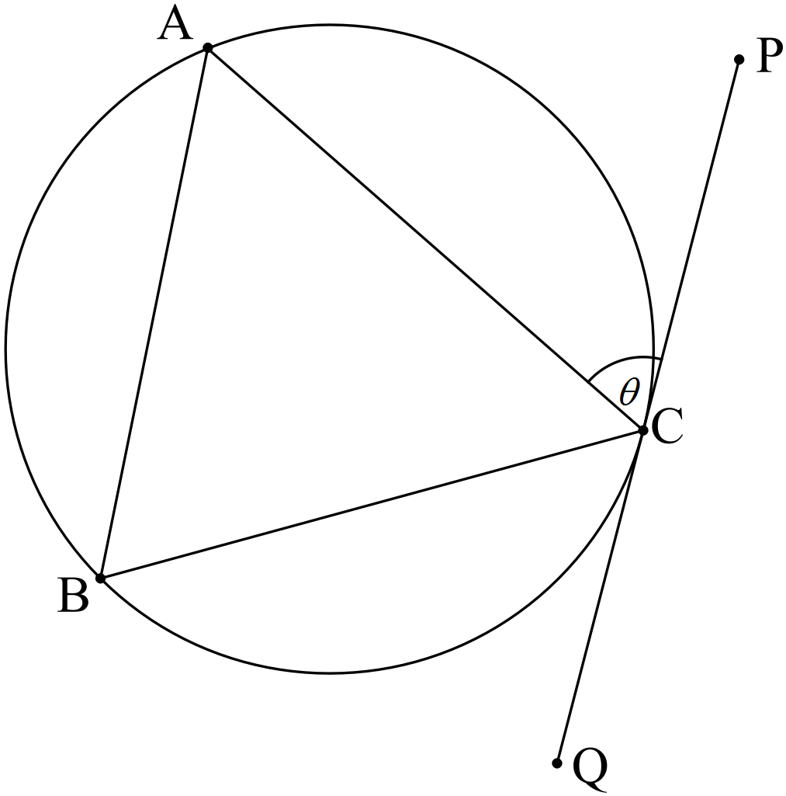

Given: PQ is tangential to the circle at C, CA = CB, .
To Prove: PQ is parallel to AB.
Proof:

Question 3 (5 marks)

Complete the following proof.
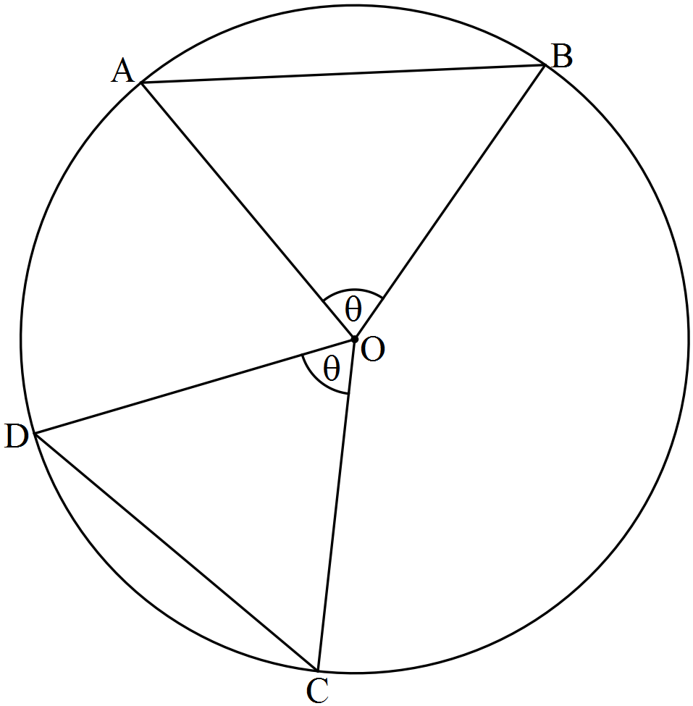

Given: Circle centre O with chords AB and CD, .
To Prove: Chords AB and CD are equal in length.
Proof:

Question 4 (4 marks)

Complete the following proof.
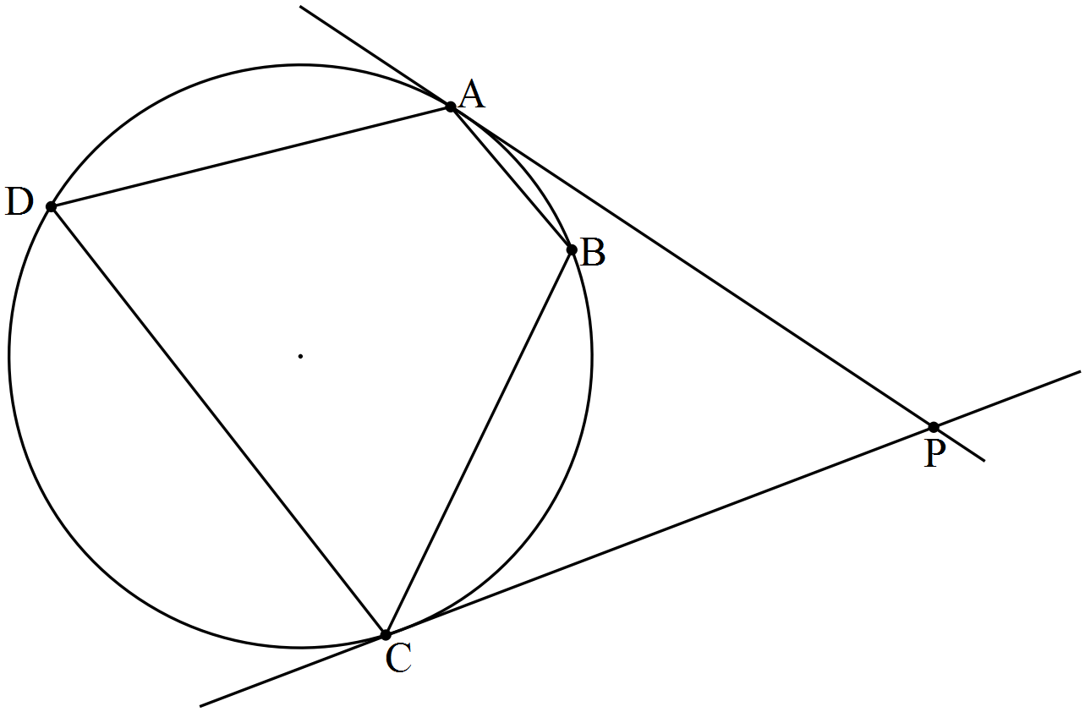
Given: A, B, C and D are four points on a circle such that ABC form a minor arc of the circle. The tangents at A and C meet at P.
To Prove:

Question 5 (6 marks)

Complete the following proof.
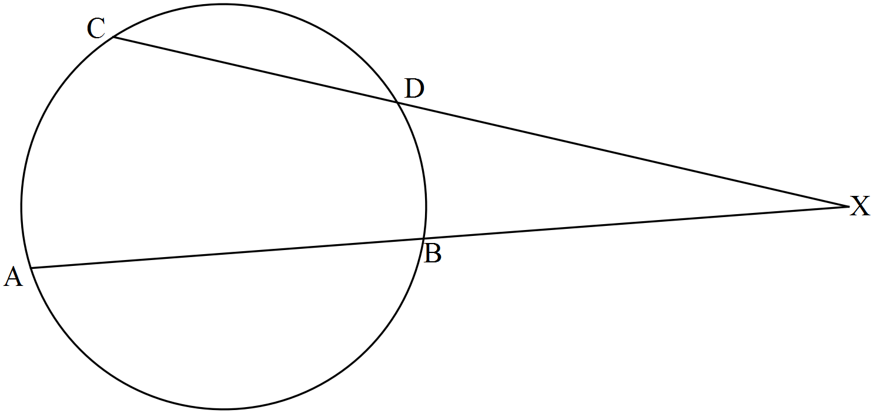

Given: Circle centre O with chords AB and CD intersecting externally at X.
To Prove: XA.XB = XC.XD

Question 6 (5 marks)

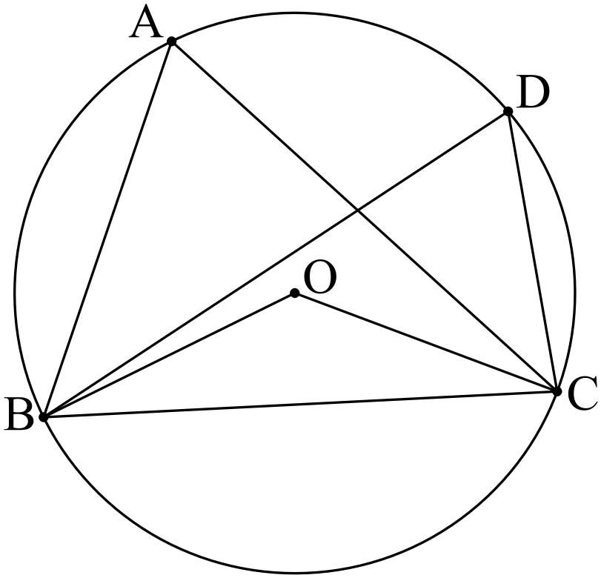
Given and , determine the size of

Question 7 (6 marks)

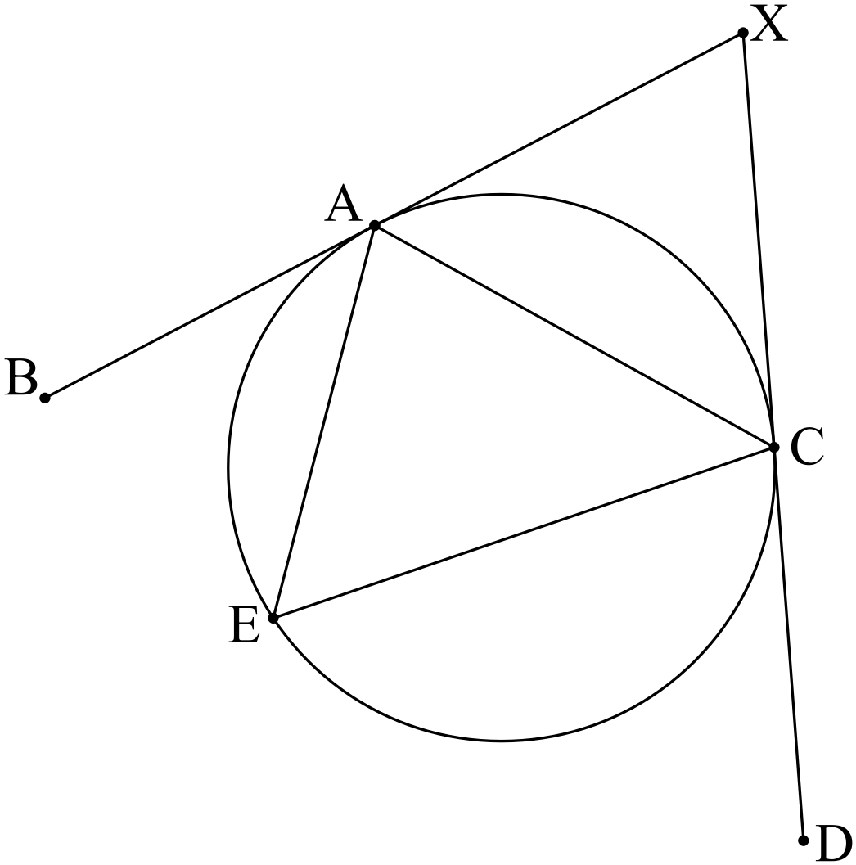
Given XB and XD are tangents, and , determine the size of

